Query a list of **CITY** and **STATE** from the **STATION** table.  
The **STATION** table is described as follows:  
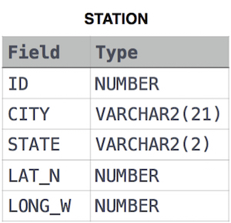

where **LAT_N** is the northern latitude and **LONG_W** is the western longitude.

Ans;

select CITY, STATE from STATION;